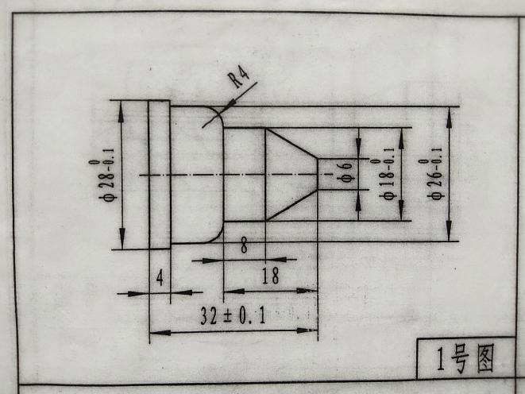

O0001;

M03 S400;

T0101;

G00 X35;

Z2;

X6;

G01 Z0 F0.2;

X18 Z-10;

Z-18;

G03 X26 Z-22;

G01 X26 Z-28;

X28;

Z-32;

G00 X100;

Z100;

T0100;

M30;

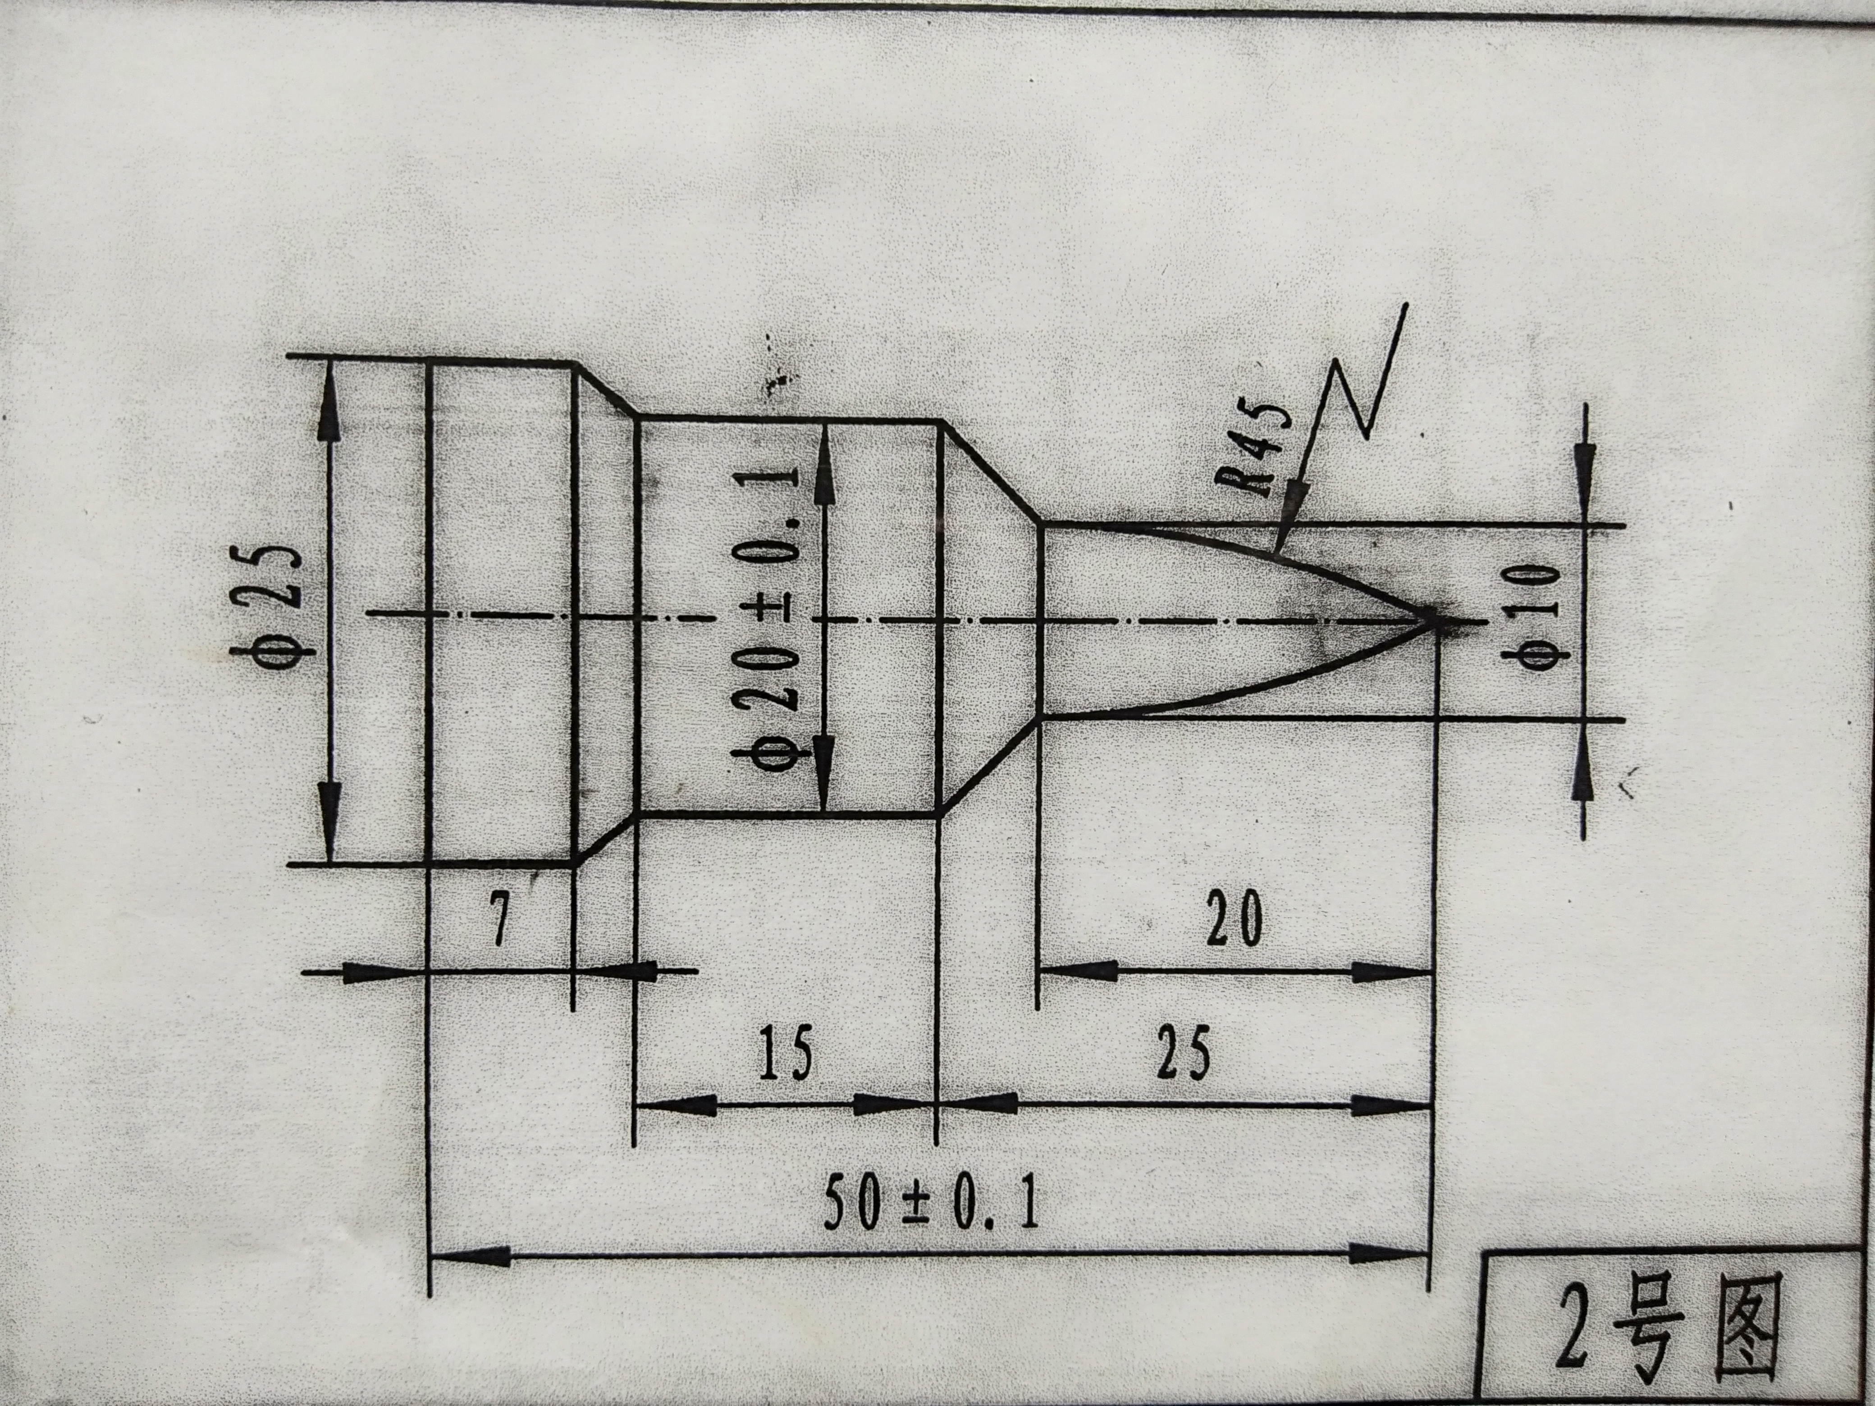

O0002;

M03 S400;

T0101;

G00 X35;

Z2;

X0;

G01 Z0 F0.2;

G03 X10 Z-20;

G01 X20 Z-25;

Z-40;

X25 Z-43;

Z-50;

G00 X100;

Z100;

T0100;

M30;

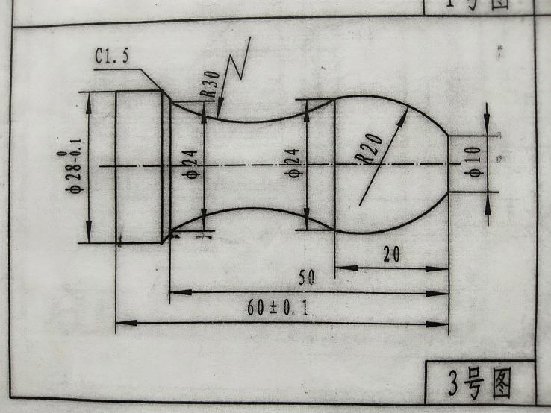

O0003;

M03 S400;

T0101;

G00 X35;

Z2;

X10;

G01 Z0 F0.2;

G03 X24 Z-20 R20;

G02 X24 Z-50 R30;

G01 X28 Z-51.5;

Z-60;

G00 X100;

Z100;

T0100;

M30;

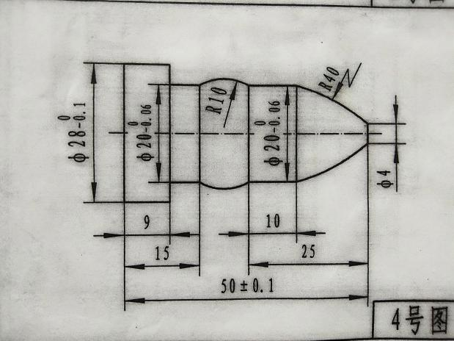

O0004;

M03 S400;

T0101;

G00 X35;

Z2;

X4;

G01 Z0 F0.2;

G03 X20 Z-15;

G01 Z-25;

G03 X20 Z-35;

G01 Z-41;

X28;

Z-50;

G00 X100;

Z100;

T0100;

M30;